**Project 1**

**Deployment the website on AWS EC2 Instance**

**Virtual private cloud**

Steps:

1. In AWS console, search VPC.
2. In VPC dashboard, you will get my VPC’s and click on myvpc’s.
3. Click on create VPC. Select resource to create as vpc only.
4. Give name as anu-vpc and IPv4 CIDR as 10.0.0.0/16.
5. Then click on create VPC.

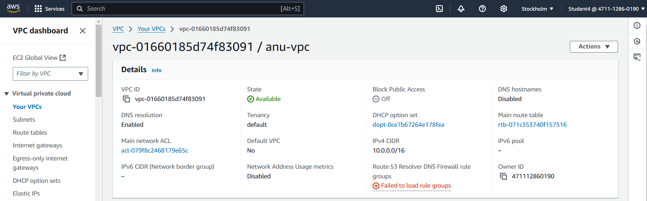

**Internet Gateway:**

Steps:

1. In VPC dashboard, click on Internet Gateway.
2. To create Internet gateway, click on create Internet Gateway.
3. Then give name as Anu-igw and click on create Internet Gateway.
4. Your internet Gateway is created.

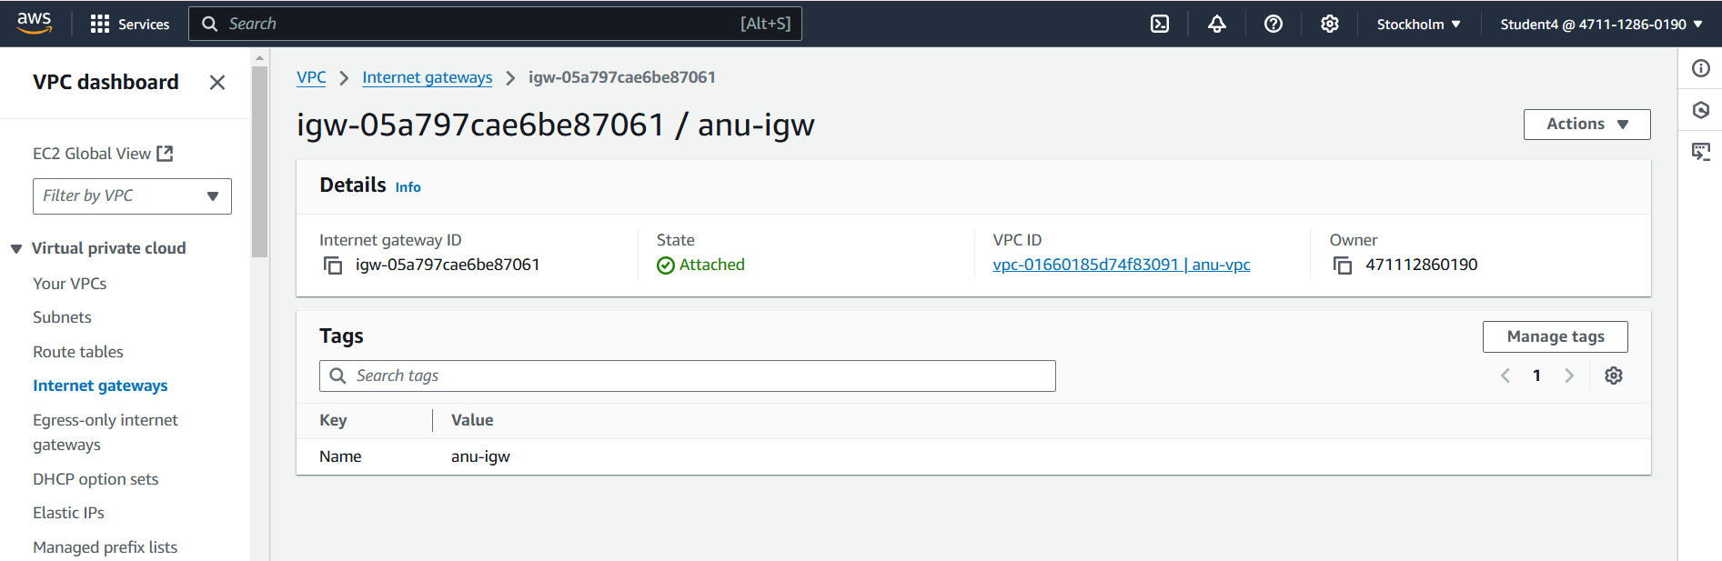

**Public Subnet 1:**

Steps:

1. To create subnet, go to VPC dashboard under virtual private cloud, click on subnet.
2. Select the vpc you have already created and in subnet setting, give subnet name as public-subnet-01 .
3. Then choose availability zone as region you have selected before creating the vpc and IPv4 subnet CIDR block as 10.0.1.0/24.
4. Then create one more subnet as following subnet but give name as public-subnet-02 and then choose availability zone and IPv4 subnet CIDR block as 10.0.2.0/24.

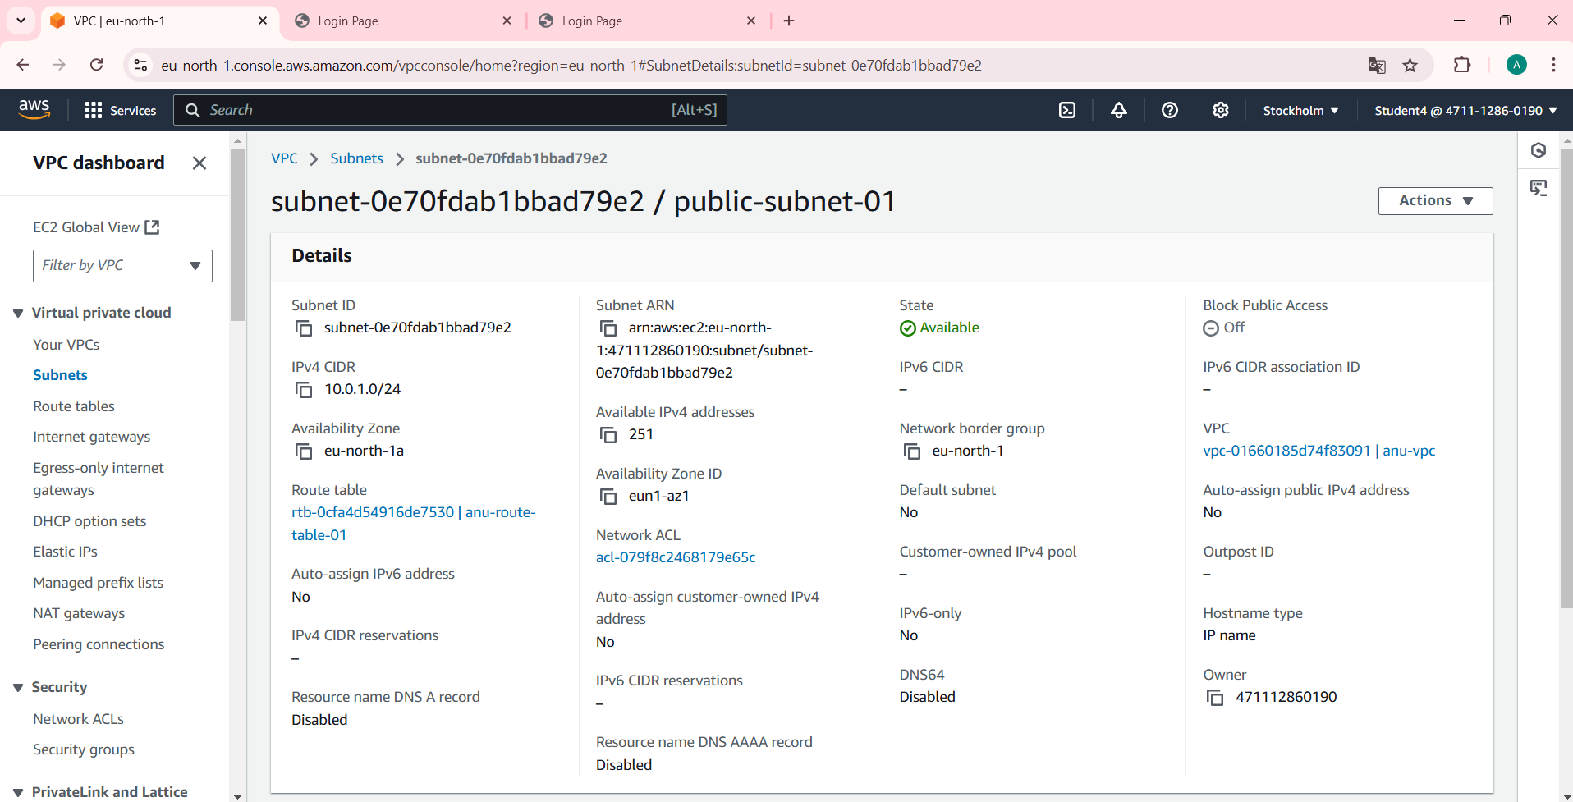

**Public subnet 2:**

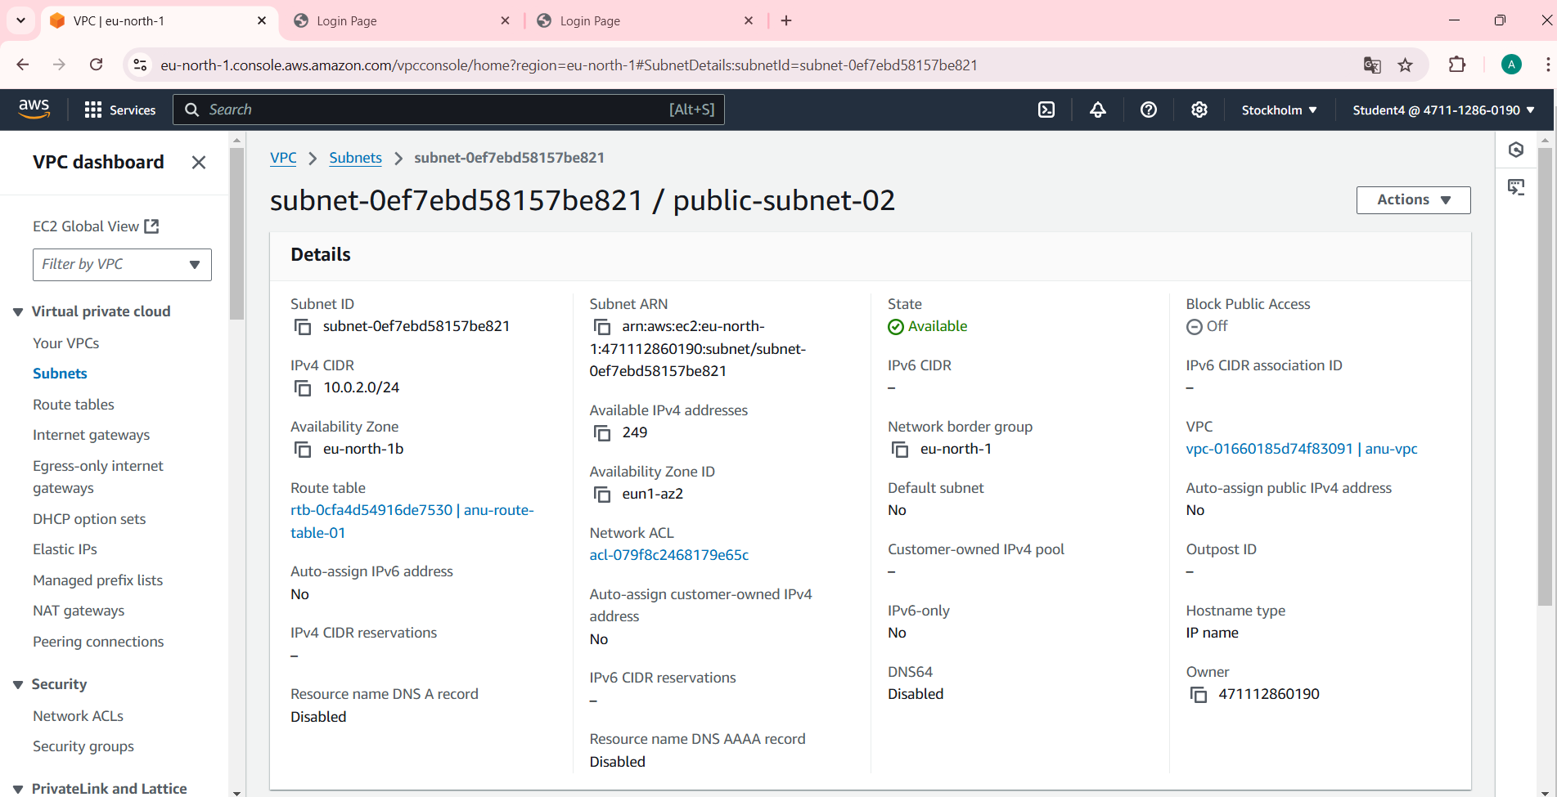

**Router Table:**

Steps:

1. To create Route table, click on create route table.
2. In route table setting, give route table name as anu-route-table-01 and select vpc that is created.
3. Then click on create route table.
4. After route table is created, go to routes and click on edit route and then click on add route.
5. Then in destination, select 0.0.0.0/0 as destination and target as Internet Gateways.
6. After selecting internet gateway, it allows to select the igw- and select the internet gateway that is created by you.
7. At last click on save changes.
8. Then go to subnet association and click on edit subnet association.
9. Select the subnet you have created and click on save changes.

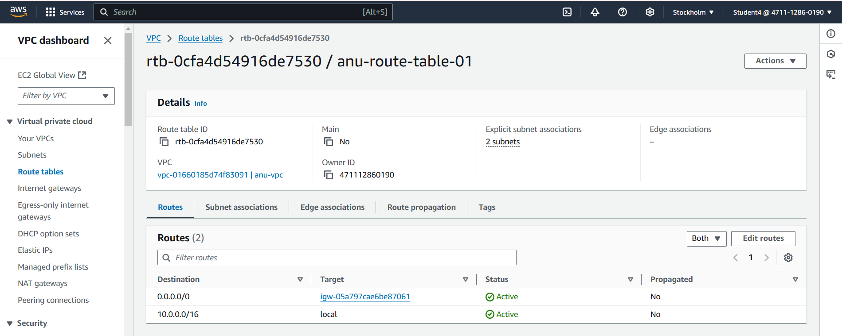

**EC2 Instance:**

Steps:

1. Go to EC2 in AWS console and click on instances.
2. Click on launch instance and give the name for the instances as anu-server.
3. After giving name to instances, select application and OS Images as Amazon Linux and instances type as t2.micro.
4. In keypair, click on create keypair and give keypair name as anu-keypair and click on create keypair. The keypair is created.
5. Then in network setting, click edit. Select vpc and subnet and also assign public IP as enable.
6. After that in security group, give name as anu-server-SG and in Inbound Security Group Rules, select type as SSH and source type as anywhere.
7. Create two more inbound security group rules, select type as http and https and source type as anywhere for both types.
8. The configure storage should be 8 GiB and root volume as gp3.
9. Then click on launch instances. Your instances have been created.

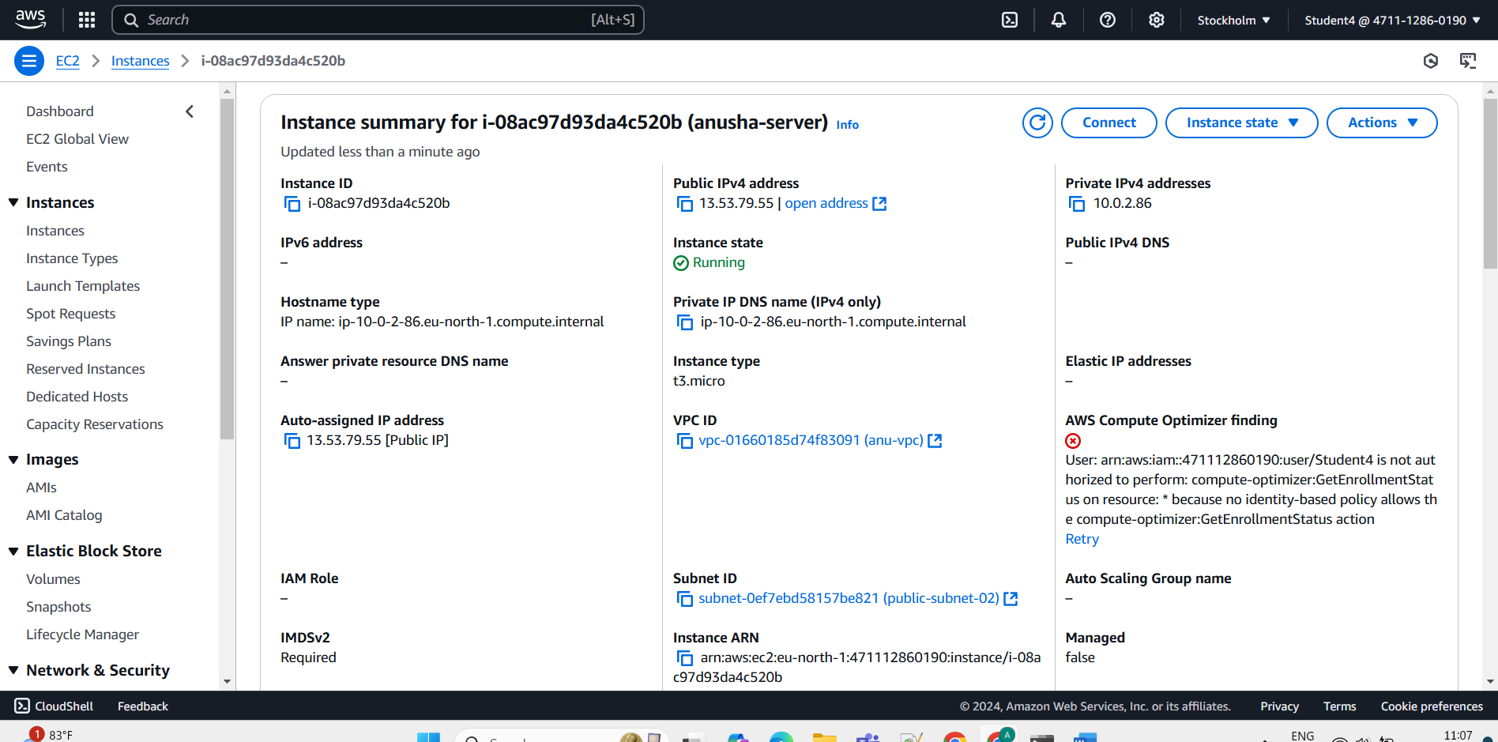

**Connection**

Steps:

1. Select the instance you have created and click on connect.
2. Go to SSH client. Copy the example.

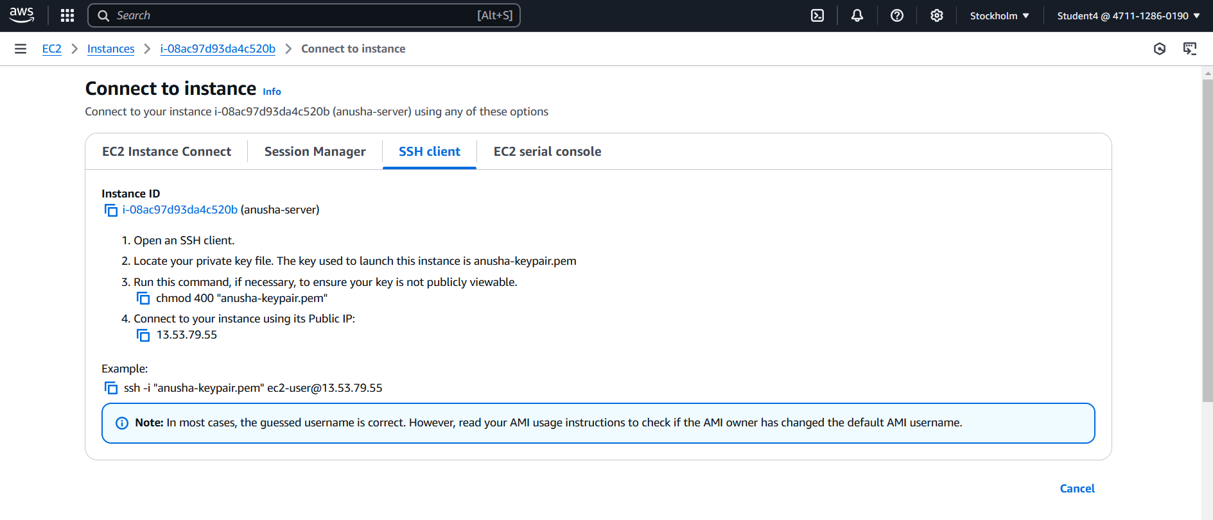

**Command prompt:**

Steps:

1. Go to command prompt and follow the following the commands:

* Cd Downloads
* Paste the SSH client example.
* Yow will get to confirm the connecting, type yes.
* Then type sudo su and cd.
* Then type yum install httpd -y.
* After installation, type cd /var/www/html.
* Then type vi index.html and vi editor will get opened and press i to insert the content.
* After that, press esc and :wq to save the content.
* Go to instances, copy the public ip and paste on browser url.

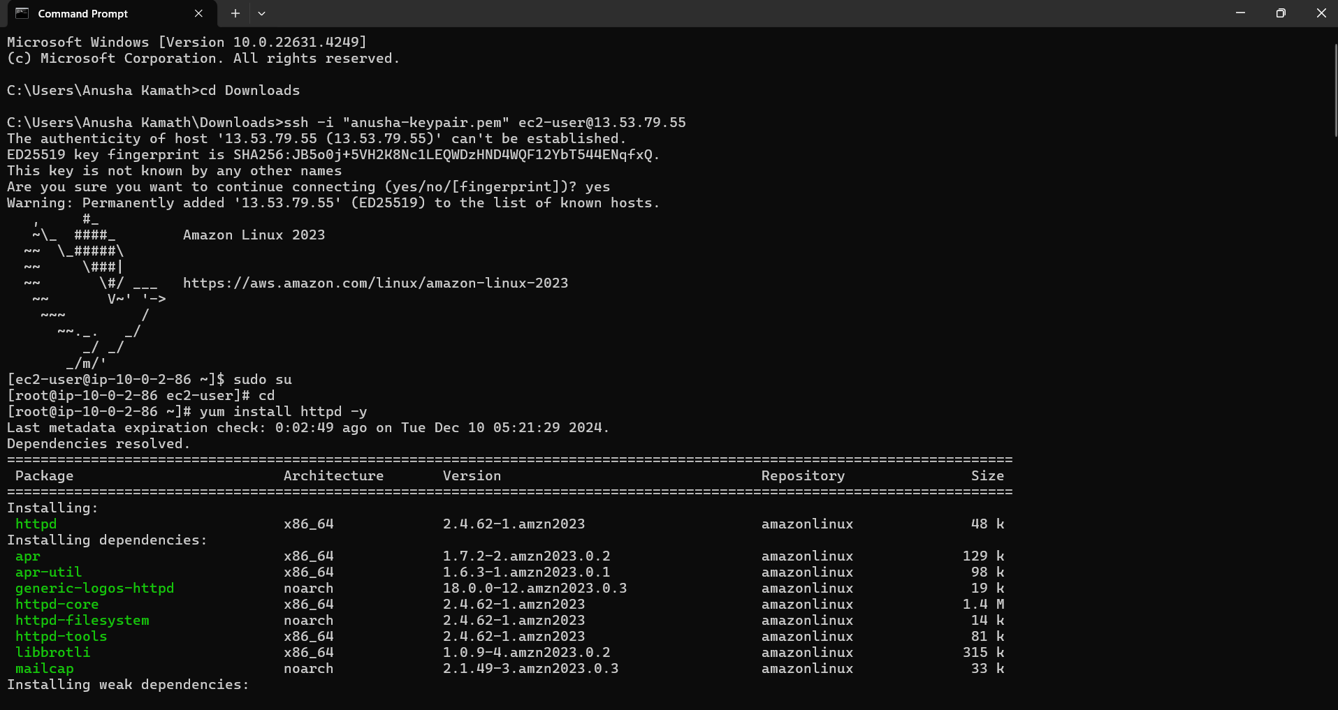

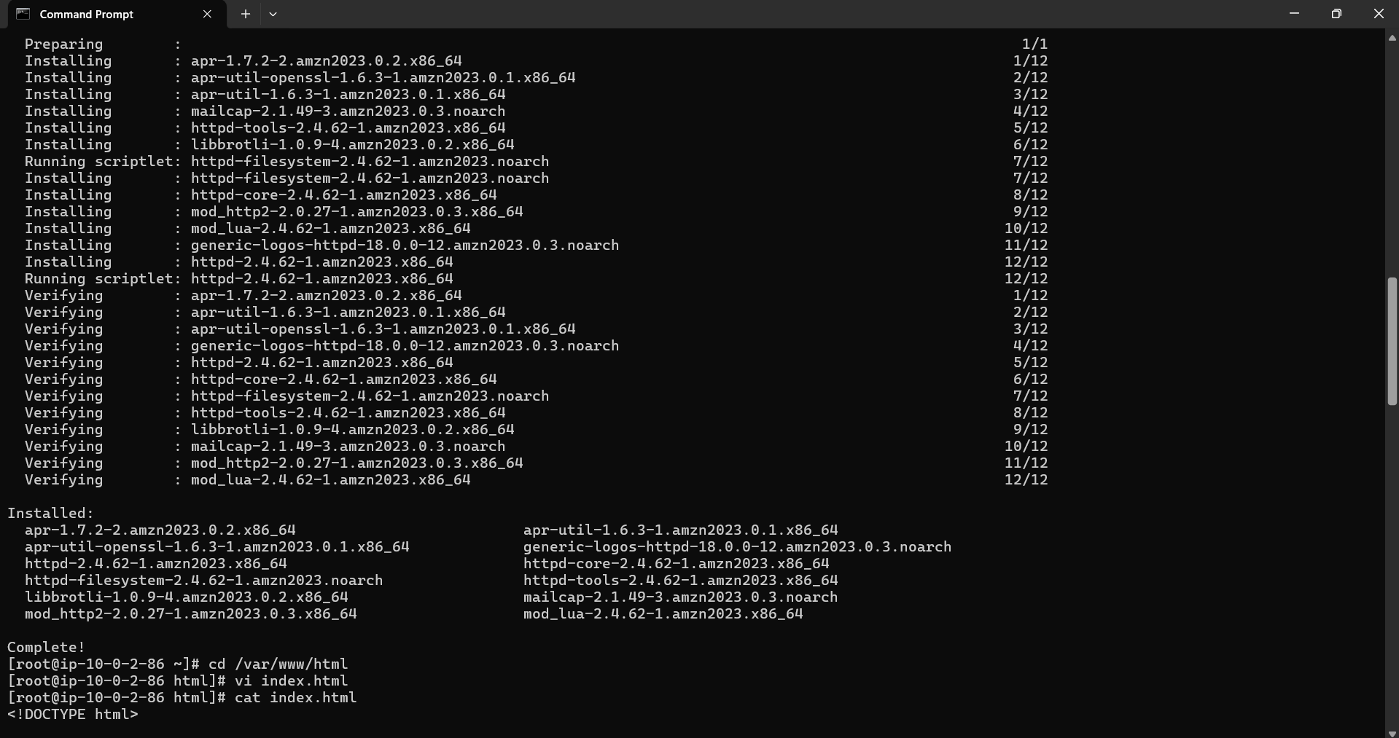

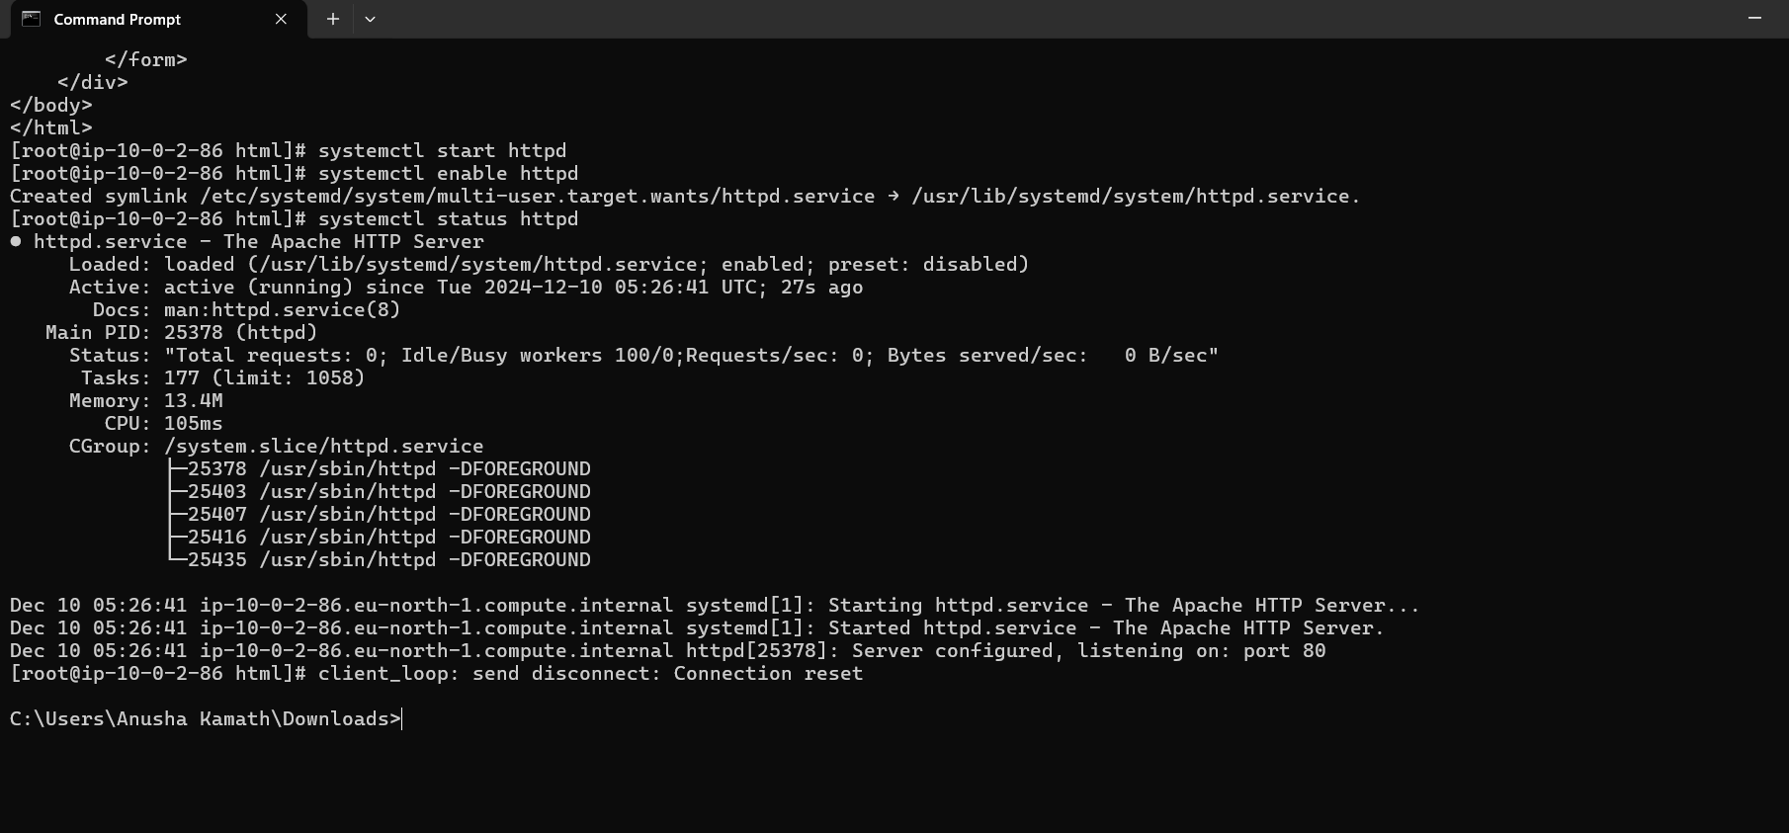

**Final Result:**

